To help you plan your exhibit, lay out your exhibit to scale on the following page. Below is an example showing what should be included on the grid. A copy of your layout should be sent to GES and your EAC, if applicable. Also notify GES of any special requirements that will need pre- show attention. Be sure to include your booth number on the grid and outline the perimeter of your exhibit in a heavy black line.

IMPORTANT: THIS FORM IS MANDATORY FOR ALL BOOTHS 200 ft² AND LARGER AND ALL BOOTHS WITH HEAVY MACHINERY

Please email your grid to Autymn Gelette, GES at agelette@ges.com

Company SME Canada Booth # 981

Person responsible John Smith Scale: 1 square = 2’ x 2’

These items should be considered when planning your exhibit:

- Machinery positions and viewing areas for demonstrations
- Electrical, air, and water lines
- Office or desk area and telephone location
- Walk thru traffic flow
- Type of floor covering (if any)
North
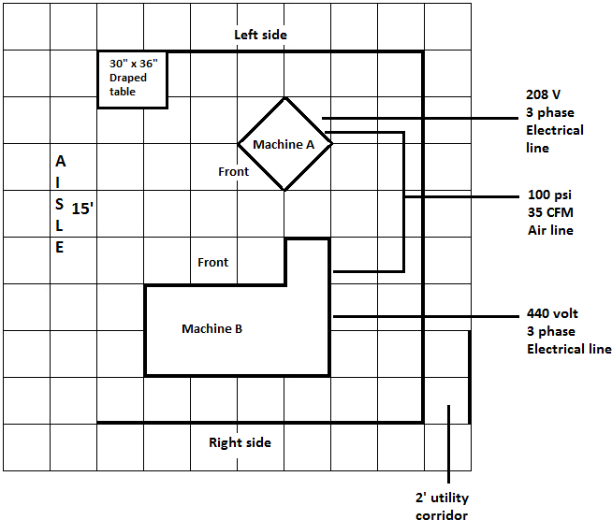

Company: Booth #

Person responsible: Scale: 1 square =

